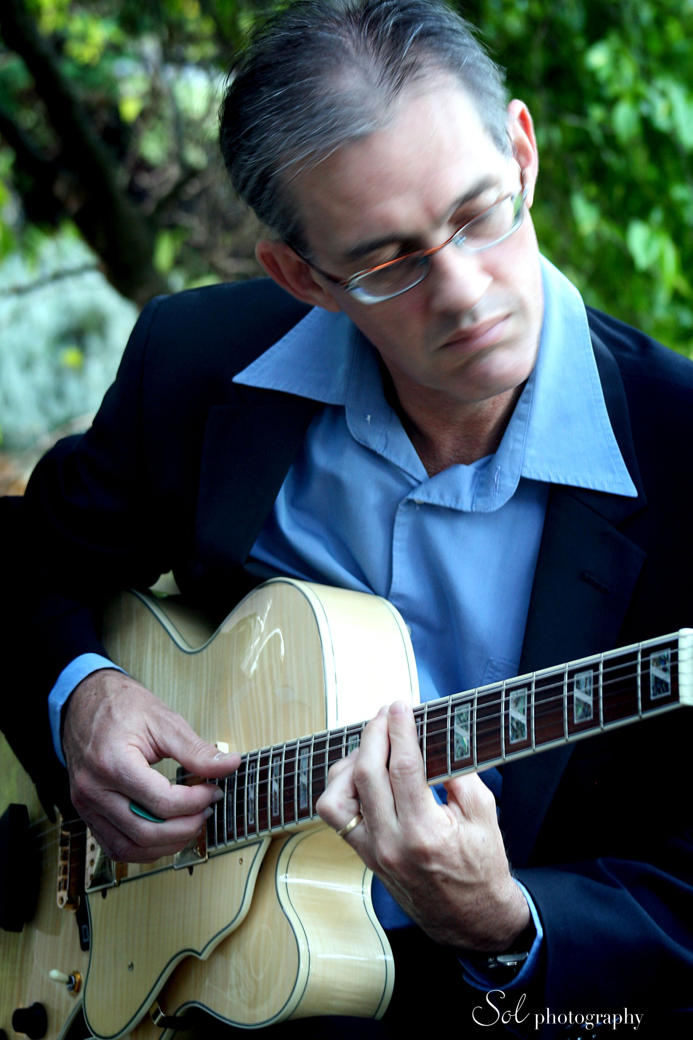
ANDREW HOBLER

GUITARIST
4 Atomi Place
Mudgeeraba Q 4213
(07) 5530 3219
0401 0767 04
email ahobler@optusnet.com.au
www www.andrewhobler.com http://www.broadjam.com/andrewhobler

Since 1989 Andrew has performed locally, interstate and internationally in a wide variety of music genes and venues.

His instrumental solo guitar work is always enjoyed by clients and customers as he plays a varied repertoire of pop, jazz, blues, soul, funk and Spanish styles.
Andrew enjoyed a long-term residency at Mudgeebah Café where his beautiful music created a relaxing afternoon ambience for customers and staff alike.

He has been a featured artist at ‘Jazz in the Basement’ at Gold Coast Arts Centre on a number of occasions and has performed in many of the lounges and bars on the Gold Coast with resident bands, duos and solo. He enjoys all styles of jazz including jazz influenced pop and soul music and his contemporary jazz quartet ‘Harmonicity’ allow him to continue writing, arranging and playing in a creative environment.

Since 1994 Andrew has been a freelance guitarist working sessions with and supporting many well known Australian and international artists including James Morrison, Don Burrows, Petula Clark, The Platters, Graham Connors, Grace Knight, Anthony Warlow, Tina Arena, Rick Price, Julie Anthony, The Ten Tenors, Geoff Harvey, Venetta Fields, Doug Parkinson and many more.

The 2011 Brisbane season of the hit musical ‘WICKED’ saw Andrew take on the task of all guitars, mandolin and banjo. In December 2012 he began performances for the Brisbane season of ‘Mary Poppins’ and ‘Annie’. In Dec 2012 he completed the Brisbane season of ‘A Chorus Line’.

He has been pit guitarist in a number of other musicals including the locally produced ‘Pyjamas in Paradise’, ‘Fame’, ‘Les Miserables’, Joseph and the Amazing Technicolour Dreamcoat’ and ‘Jesus Christ Superstar’.

Andrew has worked with the Queensland Symphony and Queensland Philharmonic orchestras and performed with members of the Singapore Symphony Orchestra.

